内容6-2：基于Spring ai alibaba的智能机票助手系统

本部分内容主要实现了一个智能机票助手系统。该系统利用Spring AI Alibaba技术、向量数据库及Spring Boot+Mybatis等技术实现。

一、 项目技术介绍

1 Spring AI Alibaba
Spring AI Alibaba 是一款 Java 语言实现的 AI 应用开发框架，旨在简化 Java AI 应用程序开发，让 Java 开发者像使用 Spring 开发普通应用一样开发 AI 应用。Spring AI Alibaba 基于 Spring AI 开源项目构建，默认提供阿里云基础模型服务、开源及商业生态组件的集成与最佳实践。
Spring AI Alibaba 项目地址：https://github.com/alibaba/spring-ai-alibaba
案例地址：https://github.com/alibaba/spring-ai-alibaba/blob/main/README-zh.md

2 向量数据库及RAG
参考内容4及内容5

3 方法调用
参考内容6-1

4 Spring Boot及Mybatis

二、系统搭建准备工作
数据库及向量数据库。

1 业务数据库
采用postgreSQL数据库，数据库表构建语句如下：

（1） bookings预定表及测试数据
- 在pgAdmin工具中，右键点击数据库名称或者shemas或者tables，选择QueryTool，粘贴入如下代码创建表bookings
CREATE TABLE IF NOT EXISTS public.bookings
(
id SERIAL PRIMARY KEY, -- 使用 SERIAL 类型自动递增
booking_number VARCHAR(20) NOT NULL,
customer_id INTEGER NOT NULL,
booking_status VARCHAR(20) NOT NULL,
from_airport VARCHAR(100) NOT NULL,
to_airport VARCHAR(100) NOT NULL,
booking_class VARCHAR(20) NOT NULL,
booking_date VARCHAR -- 保持与原字段一致
);

- 运行以下语句，插入测试数据
INSERT INTO bookings(booking_number, customer_id, booking_status, from_airport, to_airport, booking_class, booking_date)
VALUES (1,1,'CONFIRMED','Beijing','Shanghai','Economy','2024-12-01');

INSERT INTO bookings(booking_number, customer_id, booking_status, from_airport, to_airport, booking_class, booking_date)
VALUES (2,2,'CONFIRMED','济南','香港','Economy','2025-01-05');

INSERT INTO bookings(booking_number, customer_id, booking_status, from_airport, to_airport, booking_class, booking_date)
VALUES (3,3,'CONFIRMED','武汉','北京','Economy','2025-01-11')

（2）创建customer表及测试数据
- 在pgAdmin工具中，右键点击数据库名称或者schemas或者tables，选择QueryTool，粘贴入如下代码创建表customers
CREATE TABLE IF NOT EXISTS public.customers
(
id SERIAL PRIMARY KEY, -- 使用 SERIAL 类型自动递增
customer_name VARCHAR(100) NOT NULL,
email VARCHAR(100),
phone VARCHAR(20)
);

- 运行以下语句，插入测试数据
在pgAdmin工具中，右键点击数据库名称或者shemas或者tables，选择QueryTool，粘贴入如下代码插入customer测试数据：

INSERT INTO customers(id, customer_name, email, phone)
VALUES
(1, '云小宝', 'yunxiaobao@example.com', '13800000001'),
(2, '李千问', 'liqianwen@example.com', '13800000002'),
(3, '张百炼', 'zhangbailian@example.com', '13800000003'),
(4, '王通义', 'wangtongyi@example.com', '13800000004'),
(5, '刘魔搭', 'liumoda@example.com', '13800000005'),
(6, '张三', 'zhangsan@example.com', '1234567890'),
(7, '李四', 'lisi@example.com', '0987654321');

三 系统实现

1 创建Spring Boot项目
新建项目，使用Spring Initializr创建Spring Boot项目，选择maven。

application.yml
server:
port: 8085
spring:
datasource:
url: jdbc:postgresql://127.0.0.1:5432/testdb
username: postgres
password: postgres
ai:
# alibaba
dashscope:
api-key: ${AI_DASHSCOPE_API_KEY}
chat:
options:
model: qwen-max
mybatis:
mapper-locations: classpath:/mapper/*.xml # 指定mapper XML文件的位置
type-aliases-package: edu.sdjzu.flightbooking.data # 指定模型类的包路径，以便可以在mapper XML中使用简单类名
configuration:
log-impl: org.apache.ibatis.logging.stdout.StdOutImpl # 使 MyBatis 使用标准输出打印 SQL
logging:
level:
org.mybatis.spring.SqlSessionFactoryBean: DEBUG # 打印 SQL 语句
org.mybatis: DEBUG # 打印所有 MyBatis 相关的日志
配置阿里大模型、关系数据库和向量数据库、Mybatis

POM.XML主要引入的依赖包括：spring-ai-alibaba-starter、spring-boot-starter-web、spring-ai-pgvector-store-spring-boot-starter等。
<properties>
<java.version>21</java.version>
<spring-ai.version>1.0.0-M3</spring-ai.version>
</properties>
<dependencies>
<dependency>
<groupId>org.springframework.boot</groupId>
<artifactId>spring-boot-starter-web</artifactId>
</dependency>
<dependency>
<groupId>com.alibaba.cloud.ai</groupId>
<artifactId>spring-ai-alibaba-starter</artifactId>
<version>1.0.0-M3.2</version>
</dependency>
<!--用于连接pgsql-->
<dependency>
<groupId>org.springframework.boot</groupId>
<artifactId>spring-boot-starter-jdbc</artifactId>
</dependency>
<!--用于使用pgvector来操作向量数据库-->
<dependency>
<groupId>org.springframework.ai</groupId>
<artifactId>spring-ai-pgvector-store-spring-boot-starter</artifactId>
</dependency>
<!--pdf解析-->
<dependency>
<groupId>org.springframework.ai</groupId>
<artifactId>spring-ai-pdf-document-reader</artifactId>
</dependency>
<!--文档解析l-->
<dependency>
<groupId>org.springframework.ai</groupId>
<artifactId>spring-ai-tika-document-reader</artifactId>
</dependency>
<dependency>
<groupId>org.projectlombok</groupId>
<artifactId>lombok</artifactId>
</dependency>
<dependency>
<groupId>cn.hutool</groupId>
<artifactId>hutool-all</artifactId>
<version>5.8.15</version>
</dependency>
<!-- MyBatis Spring Boot Starter (集成 MyBatis 和 Spring Boot) -->
<dependency>
<groupId>org.mybatis.spring.boot</groupId>
<artifactId>mybatis-spring-boot-starter</artifactId>
<version>3.0.4</version>
</dependency>
<dependency>
<groupId>org.postgresql</groupId>
<artifactId>postgresql</artifactId>
<version>42.5.4</version> <!-- 确保使用最新版 -->
</dependency>
<dependency>
<groupId>org.springframework.boot</groupId>
<artifactId>spring-boot-starter-test</artifactId>
<scope>test</scope>
</dependency>
</dependencies>
<dependencyManagement>
<dependencies>
<dependency>
<groupId>org.springframework.ai</groupId>
<artifactId>spring-ai-bom</artifactId>
<version>${spring-ai.version}</version>
<type>pom</type>
<scope>import</scope>
</dependency>
</dependencies>
</dependencyManagement>
……
<repositories>
<repository>
<id>spring-milestones</id>
<name>Spring Milestones</name>
<url>https://repo.spring.io/milestone</url>
<snapshots>
<enabled>false</enabled>
</snapshots>
</repository>
</repositories>
创建后的项目结构如下：
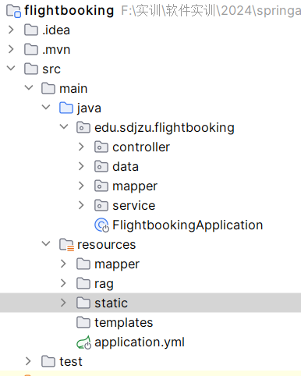

2 修改启动主类
Spring Boot启动主类FlightbookingApplication代码如下：
package edu.sdjzu.flightbooking;
import org.springframework.ai.chat.memory.ChatMemory;
import org.springframework.ai.chat.memory.InMemoryChatMemory;
import org.springframework.boot.SpringApplication;
import org.springframework.boot.autoconfigure.SpringBootApplication;
import org.springframework.context.annotation.Bean;
@SpringBootApplication
public class FlightbookingApplication {
public static void main(String[] args) {
SpringApplication.run(FlightbookingApplication.class, args);
}
// Spring应用上下文加载完成后初始化向量数据库
@Bean
public VectorStore pgvectorStore(JdbcTemplate jdbcTemplate, EmbeddingModel embeddingModel) {
VectorStore vectorStore = new PgVectorStore("flight_vector",jdbcTemplate, embeddingModel, -1, PgVectorStore.PgDistanceType.COSINE_DISTANCE, false
, PgVectorStore.PgIndexType.IVFFLAT, true);
return vectorStore;
}
// 初始化会话记忆
}

Springboot项目启动后会注入pgvectorStore和chatMemory对象。pgvectorStore对象会自动在当前postgreSQL中创建一个名为flight_vector的表（public模式），若已存在则不创建。后续上传的知识库文档都会被存到这个表中。

3实现向量数据上传功能
该功能描述：打开一个上传页面，选择飞机订票规则文本，上传到向量数据库flight_vector。

（1）在controller包新建RagController.java
@RestController
@RequestMapping("/rag")
public class RagController {
@Autowired
private DocumentService documentService;
//上传文档
@PostMapping("/upload")
public ResponseEntity upload(@RequestBody MultipartFile file) {
documentService.uploadDocument(file);
return ResponseEntity.ok("success");
}
//搜索文档
@GetMapping("/search")
public ResponseEntity<List<Document>> searchDoc(@RequestParam String keyword) {
return ResponseEntity.ok(documentService.search(keyword));
}

(2) 在service包下，建立DocumentService.java，注入pgvectorStore，提供上传和检索功能
@Service
public class DocumentService {

private final VectorStore vectorStore;
private final ChatClient chatClient;
private final DocumentTransformer transformer;

public DocumentService(VectorStore pgvectorStore,ChatClient.Builder builder) {

this.vectorStore = pgvectorStore;
this.chatClient = builder.build();
this.transformer = new TokenTextSplitter();
}
/**
* 上传文件，并拆分文档，向量化到数据库
* @param file 文件
*/
public void uploadDocument(MultipartFile file) {
Resource resource = file.getResource();
TikaDocumentReader reader = new TikaDocumentReader(resource);
// 读取文档
List<Document> documents = reader.get();
// 拆分文档 将文本内容划分成更小的块
List<Document> transform = transformer.transform(documents);
// 向量化到数据库
vectorStore.add(transform);
}

/**
* 根据关键词搜索向量库
* @param keyword 关键词
* @return 文档列表
*/
public List<Document> search(String keyword) {
SearchRequest searchRequest = SearchRequest.query(keyword);
searchRequest.withSimilarityThreshold(0.4);

List<Document> docs = vectorStore.similaritySearch(searchRequest);
return docs;
}
}

（3）在resources下新建文件夹rag，复制压缩包中的“部分代码”中的terms-of-service.txt，粘贴到该文件夹。
目录如下：
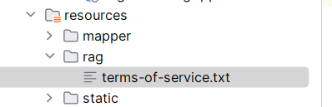
该文本内容主要是订票的条款规定。本次实现的第一个功能是将该文本上传到向量数据库vector_store中。

（4）静态文件
复制复制压缩包中的“部分代码”中的static文件夹到项目resources下。
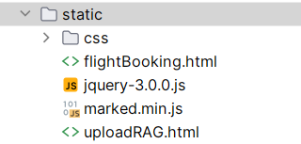
flightBooking.html 核心代码（智能代理使用fetch向后端发送异步请求，调用聊天接口，注意根据自己项目的实际情况修改调用的url）
……
// 发送消息
function sendMessage() {
const message = $("#message").val();
if(message==""||message==undefined){
alert("消息不能为空");
$("#message").focus();
return;
}
const userdivstr = "<div><h4>"+username+"</h4><div class='message' name='user'>"+message+"</div></div>";
$("#dialogwin").append(userdivstr);
const assistantdivstr = "<div><h4>"+assistantname+"</h4><div class='message' name='assistant'>正在思考……</div></div>";
$("#dialogwin").append(assistantdivstr);
$("#dialogwin").scrollTop($("#dialogwin").prop("scrollHeight"));

$("#message").val("");

const url = "http://localhost:8085/ai/assistant";
const params = {
"chatId":username,
"userMessageContent":message
};
// 将对象转换为URL查询参数
const queryParams = new URLSearchParams(params).toString();
// 调用后端接口，并传递参数
fetch(url+`?${queryParams}`,{method:'GET'})
.then(response => {
if (response.ok) {
// 解析JSON格式的响应数据
return response.text();
}
// 如果响应状态码不是2xx，抛出错误
throw new Error('Network response was not ok.');
})
.then(data => {
// 你可以将数据渲染到页面上
$('#dialogwin div[name="assistant"]').last().html(marked(data));
$('#dialogwin').scrollTop($('#dialogwin').prop("scrollHeight"));

console.log("本次请求接收字节数为："+data.length);
}).catch(error => {
$('#dialogwin div[name="assistant"]').last().html('流数据抓取失败:'+ error);
});
}

（5）在浏览器打开上传页面，选择rag目录中的txt文件，选择上传。
http://localhost:8085/uploadRAG.html

4 实现flightbooking（飞机订票）业务

（1）数据模型或实体类
- 在controller同级目录下，新建data包，并新建Booking订单实体类：
public class Booking {
private Integer id;
private String bookingNumber;
private String bookingDate;
private Customer customer;
private String from;
private String to;
private String bookingStatus;
private String bookingClass;
…… 省略getter/setter
}
- 在data包下新建实体类Customer.java
public class Customer {
private int id;
private String name;
private String email;
private String phone;
private List<Booking> bookings = new ArrayList<>();
public Customer() {
}
public Customer(String name) {
this.name = name;
}
…… 省略getter/setter
- 在data包下新建BookingData.java

public class BookingData {
private List<Customer> customers = new ArrayList<>();
private List<Booking> bookings = new ArrayList<>();
…… 省略getter/setter
}

（2） 在controller同级包下新建包mapper，存放mybatis mapper接口类，并在该包下新建BookingMapper.java接口。
package edu.sdjzu.flightbooking.mapper;
import edu.sdjzu.flightbooking.data.Booking;
import edu.sdjzu.flightbooking.data.Customer;
import org.apache.ibatis.annotations.Mapper;
import org.apache.ibatis.annotations.Param;
import java.util.List;
@Mapper
public interface BookingMapper {
// 查询预定信息，根据预定号和客户姓名
Booking findBooking(@Param("bookingNumber") String bookingNumber, @Param("name") String name);
// 查询所有预定信息
List<Booking> findAllBookings();
// 插入新的预定
int insertBooking(Booking booking);
// 更新预定信息
int updateBooking(@Param("bookingNumber") String bookingNumber, @Param("newDate") String date,
@Param("from") String from, @Param("to") String to);
// 取消预定
int cancelBooking(@Param("bookingNumber") String bookingNumber);
// 查询客户信息
Customer findCustomerByName(@Param("name") String name);
}

（3） 在resources下新建mapper文件夹，并新建BookingMapper.xml:
<?xml version="1.0" encoding="UTF-8"?>
<!DOCTYPE mapper PUBLIC "-//mybatis.org//DTD Mapper 3.0//EN"
"http://mybatis.org/dtd/mybatis-3-mapper.dtd">
<mapper namespace="edu.sdjzu.flightbooking.mapper.BookingMapper">
<!-- 查询预定信息，根据预定号和客户姓名 -->
<select id="findBooking" resultMap="bookingResultMap">
SELECT * FROM bookings
WHERE booking_number = #{bookingNumber}
AND customer_id = (SELECT id FROM customers WHERE customer_name = #{name})
</select>
<!-- 查询所有预定信息 -->
<select id="findAllBookings" resultMap="bookingResultMap">
SELECT * FROM bookings
</select>
<!-- 插入新的预定 -->
<insert id="insertBooking" useGeneratedKeys="true" keyProperty="id">
INSERT INTO bookings (booking_number, booking_date, customer_id, booking_status, from_airport, to_airport, booking_class)
VALUES (#{bookingNumber}, #{bookingDate},
(SELECT id FROM customers WHERE customer_name = #{customer.customerName}),
#{bookingStatus}, #{from}, #{to}, #{bookingClass})
</insert>
<!-- 更新预定信息 -->
<update id="updateBooking">
UPDATE bookings
<set>
<if test="newDate != null">booking_date = #{newDate},</if>
<if test="from != null">from_airport = #{from},</if>
<if test="to != null">to_airport = #{to},</if>
</set>
WHERE booking_number = #{bookingNumber}
</update>
<!-- 取消预定 -->
<update id="cancelBooking">
UPDATE bookings
SET booking_status = 'CANCELLED'
WHERE booking_number = #{bookingNumber}
</update>
<!-- 查询客户信息 -->
<select id="findCustomerByName" resultType="edu.sdjzu.flightbooking.data.Customer">
SELECT * FROM customers WHERE customer_name = #{name}
</select>
<!-- 显式定义 resultMap 来映射查询结果 -->
<resultMap id="bookingResultMap" type="edu.sdjzu.flightbooking.data.Booking">
<id property="id" column="id"/>
<result property="bookingNumber" column="booking_number"/>
<result property="bookingDate" column="booking_date"/>
<result property="from" column="from_airport"/>
<result property="to" column="to_airport"/>
<result property="bookingStatus" column="booking_status"/>
<result property="bookingClass" column="booking_class"/>
<association property="customer" column="customer_id" javaType="edu.sdjzu.flightbooking.data.Customer"
select="findCustomerById"/>
</resultMap>
<!-- 额外的映射关系：根据 customer_id 查找 Customer -->
<select id="findCustomerById" resultType="edu.sdjzu.flightbooking.data.Customer">
SELECT id, customer_name as name,email,phone FROM customers WHERE id = #{customer_id}
</select>
</mapper>

(4) 在service包下，新建FlightBookingService.java，存放服务层操作方法，其调用mybatis mapper层。
@Service
public class FlightBookingService {
@Autowired
private final BookingMapper bookingMapper;
public FlightBookingService(BookingMapper bookingMapper) {
this.bookingMapper = bookingMapper;
}
public List<BookingTools.BookingDetails> getBookings() {
List<Booking> bookings = bookingMapper.findAllBookings();
return bookings.stream()
.map(this::toBookingDetails)
.toList();
}
private Booking findBooking(String bookingNumber, String name) {
Booking booking = bookingMapper.findBooking(bookingNumber, name);
if (booking == null) {
throw new IllegalArgumentException("Booking not found");
}
return booking;
}
public BookingTools.BookingDetails getBookingDetails(String bookingNumber, String name) {
Booking booking = findBooking(bookingNumber, name);
return toBookingDetails(booking);
}
@Transactional
public String changeBooking(String bookingNumber, String name, String newDate, String from, String to) {
Booking booking = findBooking(bookingNumber, name);
if (LocalDate.parse(booking.getBookingDate()).isBefore(LocalDate.now().plusDays(1))) {
return "起飞的24小时内部允许更改预定！";
}
if(bookingMapper.updateBooking(bookingNumber, newDate, from, to)>0) return "更改成功";
return "更改失败";
}
@Transactional
public String cancelBooking(String bookingNumber, String name) {
Booking booking = findBooking(bookingNumber, name);
if (LocalDate.parse(booking.getBookingDate()).isBefore(LocalDate.now().plusDays(2))) {
return "起飞前48小时内不允许取消！";
}
else if(bookingMapper.cancelBooking(bookingNumber)>0) return "取消成功";
return "取消失败";
}
private BookingTools.BookingDetails toBookingDetails(Booking booking) {
return new BookingTools.BookingDetails(
booking.getBookingNumber(),
booking.getCustomer().getName(),
LocalDate.parse(booking.getBookingDate()),
booking.getBookingStatus(),
booking.getFrom(),
booking.getTo(),
booking.getBookingClass().toString()
);
}
}

（5） 在service包下，新建函数调用类BookingTools.java，这些函数会暴露给spring ai聊天接口。
@Configuration
public class BookingTools {
private static final Logger logger = LoggerFactory.getLogger(BookingTools.class);
@Autowired
private FlightBookingService flightBookingService;
public record BookingDetailsRequest(String bookingNumber, String name) {
}
public record ChangeBookingDatesRequest(String bookingNumber, String name, String date, String from, String to) {
}
public record CancelBookingRequest(String bookingNumber, String name) {
}
@JsonInclude(Include.NON_NULL)
public record BookingDetails(String bookingNumber, String name, LocalDate date, String bookingStatus,
String from, String to, String bookingClass) {
}
@Bean
@Description("获取机票预定详细信息")
public Function<BookingDetailsRequest, BookingDetails> getBookingDetails() {
return request -> {
try {
return flightBookingService.getBookingDetails(request.bookingNumber(), request.name());
}
catch (Exception e) {
logger.warn("Booking details: {}", NestedExceptionUtils.getMostSpecificCause(e).getMessage());
return new BookingDetails(request.bookingNumber(), request.name(), null, null, null, null, null);
}
};
}
@Bean
@Description("修改机票预定日期")
public Function<ChangeBookingDatesRequest, String> changeBooking() {
return request -> {
String result = flightBookingService.changeBooking(request.bookingNumber(), request.name(), request.date(), request.from(),
request.to());
return result;
};
}
@Bean
@Description("取消机票预定")
public Function<CancelBookingRequest, String> cancelBooking() {
return request -> {
String result = flightBookingService.cancelBooking(request.bookingNumber(), request.name());
return result;
};
}
}

（6）在controller包下新建BookingController.java，用于进入页面时查询出所有订单。代码如下：
@RestController
@RequestMapping("/booking")
public class BookingController {
@Autowired
private FlightBookingService flightBookingService;
@GetMapping(value ="/all")
public List<BookingTools.BookingDetails> getBookings() {
List<BookingTools.BookingDetails> bookingDetails = flightBookingService.getBookings();
return bookingDetails;
}
}

5 聊天机器人控制器实现
在controller包下，新建CustomerSupportAssistant.java。
该类是聊天机器人主要控制器，用于接受用户聊天请求，构建聊天客户端，配置聊天代理的各项属性，包括系统提示词、默认advisors建议者、函数调用等。
CustomerSupportAssistant 构造函数：
- ChatClient.Builder：构建 ChatClient 实例。ChatClient 是与 AI 模型进行交互的核心对象。
- defaultSystem：设置系统的默认行为和提示信息，模拟一个“友好”的客户服务助手。提示中包含了模型行为的规范，例如，它应始终以友好、乐于助人的方式回应用户，要求用户提供预订号和客户姓名等信息。
• defaultAdvisors：设置不同的顾问（advisors），顾问负责引导和增强模型的行为。
- PromptChatMemoryAdvisor：用于处理聊天内存，保存与用户的对话历史。
- QuestionAnswerAdvisor：集成了外部的向量存储和搜索功能，提供基于问题的回答（RAG，Retrieval-Augmented Generation）。
- SimpleLoggerAdvisor：用于记录日志。
• defaultFunctions：定义可以调用的函数，例如 getBookingDetails、changeBooking 和 cancelBooking。这些函数用于处理实际的预订管理任务。
代码如下：
package edu.sdjzu.flightbooking.controller;
import org.springframework.ai.chat.client.ChatClient;
import org.springframework.ai.chat.client.advisor.PromptChatMemoryAdvisor;
import org.springframework.ai.chat.client.advisor.QuestionAnswerAdvisor;
import org.springframework.ai.chat.client.advisor.SimpleLoggerAdvisor;
import org.springframework.ai.chat.memory.ChatMemory;
import org.springframework.ai.vectorstore.SearchRequest;
import org.springframework.ai.vectorstore.VectorStore;
import org.springframework.http.MediaType;
import org.springframework.web.bind.annotation.GetMapping;
import org.springframework.web.bind.annotation.RequestMapping;
import org.springframework.web.bind.annotation.RestController;
import reactor.core.publisher.Flux;
import java.time.LocalDate;
import static org.springframework.ai.chat.client.advisor.AbstractChatMemoryAdvisor.CHAT_MEMORY_CONVERSATION_ID_KEY;
import static org.springframework.ai.chat.client.advisor.AbstractChatMemoryAdvisor.CHAT_MEMORY_RETRIEVE_SIZE_KEY;
@RestController
@RequestMapping("/ai")
public class CustomerSupportAssistant {
private final ChatClient chatClient;
public CustomerSupportAssistant(ChatClient.Builder modelBuilder, VectorStore pgvectorStore, ChatMemory chatMemory) {
// @formatter:off
this.chatClient = modelBuilder
.defaultSystem("""
您是“Funnair”航空公司的客户聊天支持代理。请以友好、乐于助人且愉快的方式来回复。
您正在通过在线聊天系统与客户互动。
在提供有关预订或取消预订的信息之前，您必须始终
从用户处获取以下信息：预订号、客户姓名。
在询问用户之前，请检查消息历史记录以获取此信息。
在更改预订之前，您必须确保条款允许这样做。
如果更改需要收费，您必须在继续之前征得用户同意。
使用提供的功能获取预订详细信息、更改预订和取消预订。
如果需要，可以调用相应函数调用完成辅助动作。
绝大多数情况下，你是需要调用相应函数来完成相关操作的，调用函数时有返回值也请返回。
如果调用函数发生异常，请回复：操作失败，请重新提问。
如果执行更改或更新信息或取消预定等操作时应让用户确认再进行函数调用。
由于系统限制，还不能更改机票类别和预定状态。
请讲中文。
今天的日期是 {current_date}.
""")
.defaultAdvisors(
new PromptChatMemoryAdvisor(chatMemory), // Chat Memory
new QuestionAnswerAdvisor(vectorStore, SearchRequest.defaults()), // RAG
new SimpleLoggerAdvisor()) //日志输出
.defaultFunctions("getBookingDetails", "changeBooking", "cancelBooking") // FUNCTION CALLING
.build();
// @formatter:on
}
//机器人聊天入口
@GetMapping("/assistant")
public String orderDetail(String userMessageContent) {
return this.chatClient.prompt()
.system(s -> s.param("current_date", LocalDate.now().toString()))
.user(userMessageContent)
.advisors(a -> a.param(CHAT_MEMORY_CONVERSATION_ID_KEY, "1").param(CHAT_MEMORY_RETRIEVE_SIZE_KEY, 100))
.call()
.content();
}
}

6测试运行
http://localhost:8085/flightBooking.html，进行聊天。
页面显示如下效果：
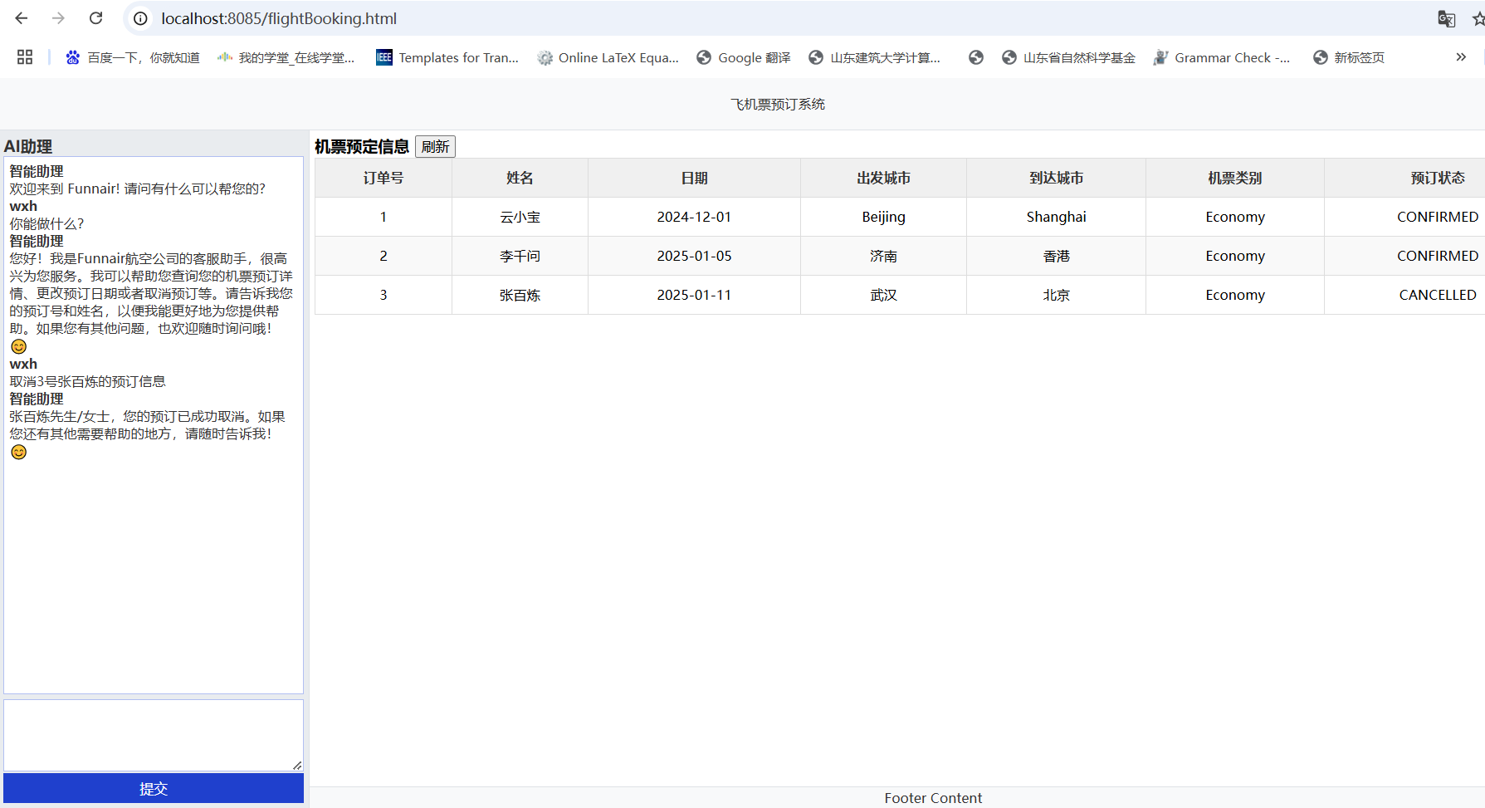
输入其他内容进行测试

四、实战内容
（1）完成项目代码编写和运行，测试聊天效果。输入不同的内容和聊天机器人交互，观察效果。观察是否可实现订单查询、更改订单、和取消订单。
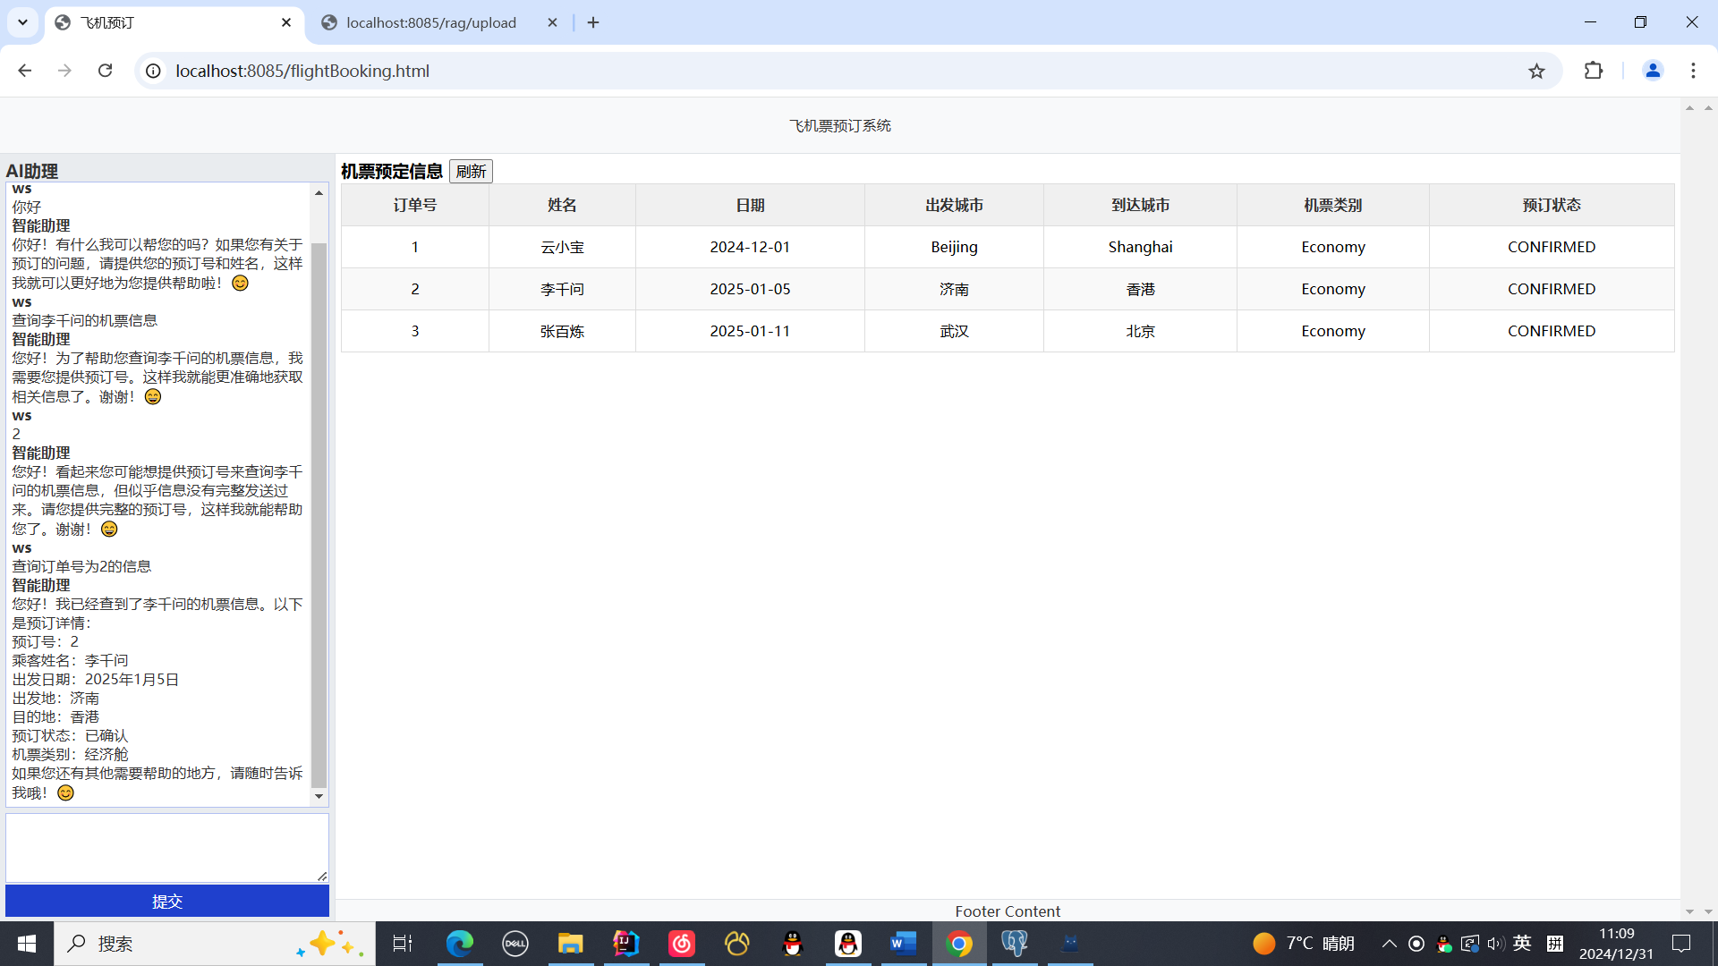
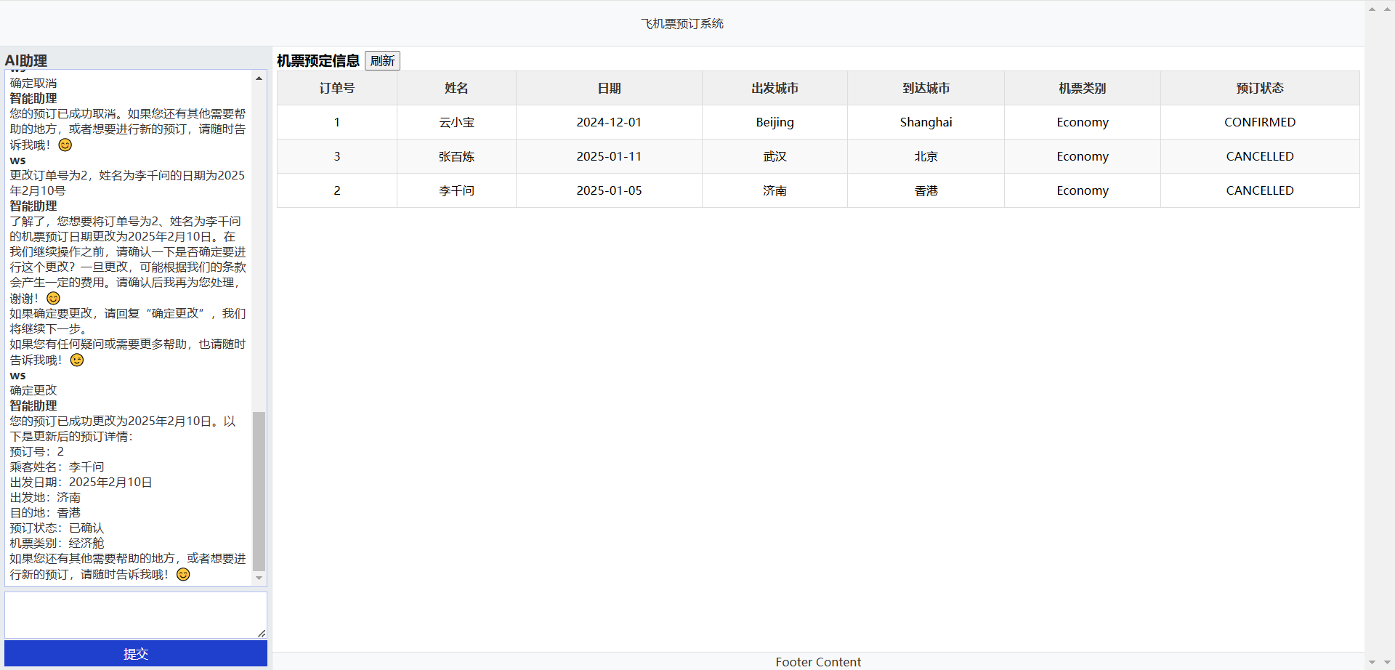
- 实训报告中展示前面内容的完成过程（图文并茂）和遇到的问题及解决思路。
package com.example.airdemo;
省略import
@SpringBootApplication
public class AirdemoApplication {

public static void main(String[] args) {
SpringApplication.run(AirdemoApplication.class, args);
}

// Spring应用上下文加载完成后初始化向量数据库
@Bean
public VectorStore pgvectorStore(JdbcTemplate jdbcTemplate, EmbeddingModel embeddingModel) {
VectorStore vectorStore = new PgVectorStore("flight_vector", jdbcTemplate, embeddingModel, -1, PgVectorStore.PgDistanceType.COSINE_DISTANCE, false
, PgVectorStore.PgIndexType.IVFFLAT, true);
return vectorStore;
}
// 初始化会话记忆
}

实现向量数据上传功能
controller
package com.example.airdemo.controller;

省略import
import java.util.List;

@RestController
@RequestMapping("/rag")

public class RagController {
@Autowired
private DocumentService documentService;

//上传文档
@PostMapping("/upload")
public ResponseEntity upload(@RequestBody MultipartFile file) {
documentService.uploadDocument(file);
return ResponseEntity.ok("success");
}
//搜索文档
@GetMapping("/search")
public ResponseEntity<List<Document>> searchDoc(@RequestParam String keyword) {
return ResponseEntity.ok(documentService.search(keyword));
}

}

service
package com.example.airdemo.service;
省略import
import java.util.List;

@Service
public class DocumentService {
private final VectorStore vectorStore;
private final ChatClient chatClient;
private final DocumentTransformer transformer;

public DocumentService(VectorStore pgvectorStore,ChatClient.Builder builder) {

this.vectorStore = pgvectorStore;
this.chatClient = builder.build();
this.transformer = new TokenTextSplitter();
}
/**
* 上传文件，并拆分文档，向量化到数据库
* @param file 文件
*/
public void uploadDocument(MultipartFile file) {
Resource resource = file.getResource();
TikaDocumentReader reader = new TikaDocumentReader(resource);
// 读取文档
List<Document> documents = reader.get();
// 拆分文档 将文本内容划分成更小的块
List<Document> transform = transformer.transform(documents);
// 向量化到数据库
vectorStore.add(transform);
}

/**
* 根据关键词搜索向量库
* @param keyword 关键词
* @return 文档列表
*/
public List<Document> search(String keyword) {
SearchRequest searchRequest = SearchRequest.query(keyword);
searchRequest.withSimilarityThreshold(0.4);

List<Document> docs = vectorStore.similaritySearch(searchRequest);
return docs;
}

}

html核心代码
<!DOCTYPE html>
<html lang="en">
<head>
<meta charset="UTF-8">
<meta name="viewport" content="width=device-width, initial-scale=1.0">
<meta http-equiv="X-UA-Compatible" content="ie=edge">
<title>文件上传</title>

<!-- 引入Bootstrap 5样式 -->
<link href="https://cdn.jsdelivr.net/npm/bootstrap@5.3.0-alpha1/dist/css/bootstrap.min.css" rel="stylesheet">

<!-- 自定义CSS -->
<style>
body {
background-color: #f4f4f9;
font-family: 'Arial', sans-serif;
color: #333;
}
.container {
max-width: 600px;
margin-top: 50px;
}
.upload-box {
background-color: #fff;
padding: 30px;
border-radius: 8px;
box-shadow: 0 0 15px rgba(0, 0, 0, 0.1);
}
.upload-box h3 {
margin-bottom: 20px;
text-align: center;
color: #007bff;
}
.upload-btn {
background-color: #007bff;
color: #fff;
border: none;
padding: 10px 20px;
border-radius: 5px;
width: 100%;
cursor: pointer;
font-size: 16px;
transition: background-color 0.3s ease;
}
.upload-btn:hover {
background-color: #0056b3;
}
.file-input {
display: none;
}
.file-label {
background-color: #28a745;
color: white;
padding: 12px 20px;
border-radius: 5px;
cursor: pointer;
text-align: center;
display: block;
margin-top: 20px;
}
.file-label:hover {
background-color: #218838;
}
.file-name {
margin-top: 10px;
font-weight: bold;
}
</style>
</head>
<body>

<div class="container">
<div class="upload-box">
<h3>上传文件</h3>

<!-- 上传表单 -->
<form action="/rag/upload" method="post" enctype="multipart/form-data">
<div class="form-group">
<label for="file" class="file-label">选择文件</label>
<input type="file" id="file" name="file" class="file-input" required>
<div id="fileName" class="file-name"></div>
</div>
<button type="submit" class="upload-btn">开始上传</button>
</form>
</div>
</div>

<!-- 引入JavaScript -->
<script>
// 显示已选择文件名
document.getElementById('file').addEventListener('change', function(event) {
const fileName = event.target.files.length > 0 ? event.target.files[0].name : '未选择文件';
document.getElementById('fileName').textContent = '选择的文件: ' + fileName;
});
</script>

<!-- 引入Bootstrap和其他JS库 -->
<script src="https://cdn.jsdelivr.net/npm/bootstrap@5.3.0-alpha1/dist/js/bootstrap.bundle.min.js"></script>
</body>
</html>

实现flightbooking（飞机订票）业务
新建BookingMapper.java接口
package com.example.airdemo.mapper;

省略import
import java.util.List;

@Mapper
public interface BookingMapper {
// 查询预定信息，根据预定号和客户姓名
Booking findBooking(@Param("bookingNumber") String bookingNumber, @Param("name") String name);
// 查询所有预定信息
List<Booking> findAllBookings();
// 插入新的预定
int insertBooking(Booking booking);
// 更新预定信息
int updateBooking(@Param("bookingNumber") String bookingNumber, @Param("newDate") String date,
@Param("from") String from, @Param("to") String to);
// 取消预定
int cancelBooking(@Param("bookingNumber") String bookingNumber);
// 查询客户信息
Customer findCustomerByName(@Param("name") String name);

}

新建FlightBookingService.java，存放服务层操作方法
package com.example.airdemo.service;

import com.example.airdemo.data.Booking;
import com.example.airdemo.mapper.BookingMapper;
import org.springframework.beans.factory.annotation.Autowired;
import org.springframework.stereotype.Service;
import org.springframework.transaction.annotation.Transactional;

import java.time.LocalDate;
import java.util.List;

@Service
public class FlightBookingService {
@Autowired
private final BookingMapper bookingMapper;

public FlightBookingService(BookingMapper bookingMapper) {
this.bookingMapper = bookingMapper;
}

public List<BookingTools.BookingDetails> getBookings() {
List<Booking> bookings = bookingMapper.findAllBookings();
return bookings.stream()
.map(this::toBookingDetails)
.toList();
}

private Booking findBooking(String bookingNumber, String name) {
Booking booking = bookingMapper.findBooking(bookingNumber, name);
if (booking == null) {
throw new IllegalArgumentException("Booking not found");
}
return booking;
}

public BookingTools.BookingDetails getBookingDetails(String bookingNumber, String name) {
Booking booking = findBooking(bookingNumber, name);
return toBookingDetails(booking);
}

@Transactional
public String changeBooking(String bookingNumber, String name, String newDate, String from, String to) {
Booking booking = findBooking(bookingNumber, name);
if (LocalDate.parse(booking.getBookingDate()).isBefore(LocalDate.now().plusDays(1))) {
return "起飞的24小时内部允许更改预定！";
}
if(bookingMapper.updateBooking(bookingNumber, newDate, from, to)>0) return "更改成功";
return "更改失败";
}

@Transactional
public String cancelBooking(String bookingNumber, String name) {
Booking booking = findBooking(bookingNumber, name);
if (LocalDate.parse(booking.getBookingDate()).isBefore(LocalDate.now().plusDays(2))) {
return "起飞前48小时内不允许取消！";
}
else if(bookingMapper.cancelBooking(bookingNumber)>0) return "取消成功";
return "取消失败";
}

private BookingTools.BookingDetails toBookingDetails(Booking booking) {
return new BookingTools.BookingDetails(
booking.getBookingNumber(),
booking.getCustomer().getName(),
LocalDate.parse(booking.getBookingDate()),
booking.getBookingStatus(),
booking.getFrom(),
booking.getTo(),
booking.getBookingClass().toString()
);
}

}

建函数调用类BookingTools.java
package com.example.airdemo.service;

import com.fasterxml.jackson.annotation.JsonInclude;
import org.slf4j.Logger;
import org.slf4j.LoggerFactory;
import org.springframework.beans.factory.annotation.Autowired;
import org.springframework.context.annotation.Bean;
import org.springframework.context.annotation.Configuration;
import org.springframework.context.annotation.Description;
import org.springframework.core.NestedExceptionUtils;

import java.time.LocalDate;
import java.util.function.Function;

@Configuration
public class BookingTools {
private static final Logger logger = LoggerFactory.getLogger(BookingTools.class);

@Autowired
private FlightBookingService flightBookingService;

public record BookingDetailsRequest(String bookingNumber, String name) {
}

public record ChangeBookingDatesRequest(String bookingNumber, String name, String date, String from, String to) {
}

public record CancelBookingRequest(String bookingNumber, String name) {
}

@JsonInclude(JsonInclude.Include.NON_NULL)
public record BookingDetails(String bookingNumber, String name, LocalDate date, String bookingStatus,
String from, String to, String bookingClass) {
}

@Bean
@Description("获取机票预定详细信息")
public Function<BookingDetailsRequest, BookingDetails> getBookingDetails() {
return request -> {
try {
return flightBookingService.getBookingDetails(request.bookingNumber(), request.name());
}
catch (Exception e) {
logger.warn("Booking details: {}", NestedExceptionUtils.getMostSpecificCause(e).getMessage());
return new BookingDetails(request.bookingNumber(), request.name(), null, null, null, null, null);
}
};
}

@Bean
@Description("修改机票预定日期")
public Function<ChangeBookingDatesRequest, String> changeBooking() {
return request -> {
String result = flightBookingService.changeBooking(request.bookingNumber(), request.name(), request.date(), request.from(),
request.to());
return result;
};
}

@Bean
@Description("取消机票预定")
public Function<CancelBookingRequest, String> cancelBooking() {
return request -> {
String result = flightBookingService.cancelBooking(request.bookingNumber(), request.name());
return result;
};
}

}

BookingController.java，用于进入页面时查询出所有订单
package com.example.airdemo.controller;

import com.example.airdemo.service.BookingTools;
import com.example.airdemo.service.FlightBookingService;
import org.springframework.beans.factory.annotation.Autowired;
import org.springframework.web.bind.annotation.GetMapping;
import org.springframework.web.bind.annotation.RequestMapping;
import org.springframework.web.bind.annotation.RestController;

import java.util.List;

@RestController
@RequestMapping("/booking")
public class BookingController {
@Autowired
private FlightBookingService flightBookingService;

@GetMapping(value ="/all")
public List<BookingTools.BookingDetails> getBookings() {

List<BookingTools.BookingDetails> bookingDetails = flightBookingService.getBookings();
return bookingDetails;
}

}

聊天机器人控制器实现
新建CustomerSupportAssistant.java
package com.example.airdemo.controller;
省略import
@RestController
@RequestMapping("/ai")
public class CustomerSupportAssistant {

private final ChatClient chatClient;
private final ChatMemory chatMemory=new InMemoryChatMemory();

public CustomerSupportAssistant(ChatClient.Builder modelBuilder, VectorStore pgvectorStore) {

// @formatter:off
this.chatClient = modelBuilder
.defaultSystem("""
您是“Funnair”航空公司的客户聊天支持代理。请以友好、乐于助人且愉快的方式来回复。
您正在通过在线聊天系统与客户互动。
在提供有关预订或取消预订的信息之前，您必须始终
从用户处获取以下信息：预订号、客户姓名。
在询问用户之前，请检查消息历史记录以获取此信息。
在更改预订之前，您必须确保条款允许这样做。
如果更改需要收费，您必须在继续之前征得用户同意。
使用提供的功能获取预订详细信息、更改预订和取消预订。
如果需要，可以调用相应函数调用完成辅助动作。
绝大多数情况下，你是需要调用相应函数来完成相关操作的，调用函数时有返回值也请返回。
如果调用函数发生异常，请回复：操作失败，请重新提问。
如果执行更改或更新信息或取消预定等操作时应让用户确认再进行函数调用。
由于系统限制，还不能更改机票类别和预定状态。
请讲中文。
今天的日期是 {current_date}.
""")
.defaultAdvisors(
new PromptChatMemoryAdvisor(chatMemory), // Chat Memory
new QuestionAnswerAdvisor(pgvectorStore, SearchRequest.defaults()), // RAG
new SimpleLoggerAdvisor()) //日志输出

.defaultFunctions("getBookingDetails", "changeBooking", "cancelBooking") // FUNCTION CALLING
.build();
// @formatter:on
}
//机器人聊天入口
@GetMapping("/assistant")
public String orderDetail(String userMessageContent) {
return this.chatClient.prompt()
.system(s -> s.param("current_date", LocalDate.now().toString()))
.user(userMessageContent)
.advisors(a -> a.param(CHAT_MEMORY_CONVERSATION_ID_KEY, "1").param(CHAT_MEMORY_RETRIEVE_SIZE_KEY, 100))
.call()
.content();
}
}

